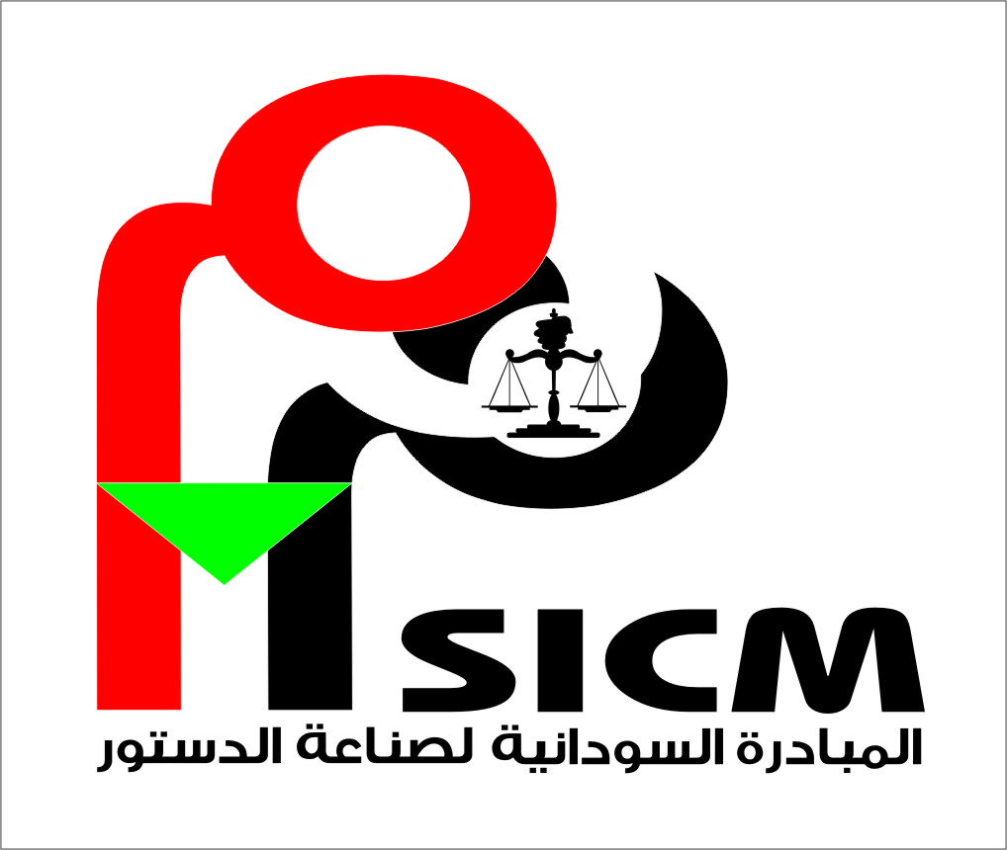

Road Map for the Constitution-Making Process
Preamble:
• Whereas the process of making a permanent constitution for the Republic of Sudan is a national issue entailing the inclusive participation of all sectors of the Sudanese people to the extent that would reflect the principle of the sovereignty of the people, add a sense of Sudanese popular ownership to the constitution and consequently, build national reconciliation, democracy, peace and development.
• In response to the conscience of Sudanese people who aspire for a democratic and free Sudan where values of the rule of law and human rights prevail and where all people peacefully co-exist without a shred of discrimination, the process of making a permanent constitution for Sudan must, therefore be inclusive, transparent, participatory and based on a legal framework that is agreed to by the different components of Sudanese society.
• Being aware of the fact that inclusive participation to the exclusion of no political, social cultural or ethnic group entails allowing the opportunity of free expression and without any restrictions or hindrance for all visions and ideas that are related to the future of Sudan. Therefore, achieving such participation would not be possible in the absence of introducing urgent legislative reforms that would create an atmosphere conducive for the birth of real democracy. This can only be attained by abolishing and repealing all freedom–restricting laws and those which clash with the Constitution to the extent that makes possible the inclusive democratic participation of all Sudanese people based on trust in institutions and laws.
• Being mindful of the fact that the process of democratic transition in Sudan can only be achieved through the participation of all Sudanese people, and by the government demonstrating political resolve to conduct the process without excluding any group or circumventing the will of the people in any way, and by bringing the people together to reach a shared agreement. ”
• Believing that making a permanent constitution for the Republic of Sudan cannot be achieved in an atmosphere marred with internal warring, it is imperative to redouble efforts to attain peace in Sudan through negotiation.
• For the sake of making a permanent constitution for the Republic of Sudan following the separation of South Sudan, in accordance with international standards that regulate procedural and technical aspects of a democratic constitution- making process that will accommodate the aspirations of Sudanese people at this point of time, the participants in the workshop of "Visions for Constitution –Making in Sudan" held in December 19th- 21st, 2011 have agreed on the following:

General Principles:
The process to draft and negotiate the new Constitution shall be based on the following principles, and pledge to promote their adoption:
1. Consensus and national ownership;
2. Dialogue, negotiation and reconciliation among the peoples of Sudan;
3. Inclusiveness: An inclusive constitution making process is one that reflects the diversity of Sudan, and where representatives of all components of society are, wherever possible, given a seat at the table so that each has a hand in the negotiation and drafting of the document and each feels secure as a valued component of the new nation;
4. Political parties, civil society organizations, professional associations, and youth groups, different ethnic, linguistic, cultural and religious groups, women, and diaspora must be able to meaningfully participate in and contribute to the constitution making process;
5. Public participation: A participatory constitution-making process is one where the people are educated about the process and the choices being decided, and are given a free, fair, and genuine opportunity to directly express their will in a secure forum that is facilitated by those tasked with analyzing and incorporating the people’s views into the constitutional draft. Education and awareness raising should be conducted by both official bodies and civil society;
6. Transparency: A transparent constitution-making process is one that is conducted in an open manner so it is easy for the public to see what actions are performed and people are aware of what is happening at each stage of the process and are confident that their voices are heard. Transparency requires, as much as appropriate, access to constitution making documents and proceedings by the media and general public;
7. Consensus: A constitution making process based on consensus is one where decisions are reached by drafting and ratifying bodies based on discussion, negotiation, and persuasion, and only as a last resort by majority rules; and
8. In order for the constitution making process to be conducted in a democratic and free manner, the relevant national authorities must ensure that constitutional reform procedures have been completed by abolishing all freedom-restricting laws.
The Stages of the Constitution-Making Process:
First stage: Agreement on constitution –making principle and institutions:
The most important stage in a constitution–making process is the preparatory stage for the sake of which all Sudanese people must come to an agreement on the goals, principles, stages, institutions, tasks and time frames of the constitution–making process. Participants in the workshop have, in this respect, agreed that:
1. The constitution–making process must, during all of its stages be democratic, representative, transparent, fair and based on agreement so that it truly represents all the components of the Sudanese people without a shred of discrimination.
2. The process of representation and agreement on the constitution–making process, steps and stages must include all groups of Sudanese people to the exclusion of none, including but not exclusive to the following groups and categories: political parties, NGOs, women, youth and student groups, people with special needs, professional and craftsmen trade unions, farmers and nomad unions, business men, native administrators, IDPs, Sudanese in the Diaspora, minorities, regular forces and any other groups to be agreed on their representation.
3. The constitution–making process derives its legitimacy from a law that is agreed on by all components of the Sudanese people. The law should determine the nature, composition, tasks and roles of the institutions. Such a law should also provide for time frames, adoption by national referendum, and allow the constitution–making process be subject to local and international monitoring and observation.
Second stage: Formation of the Constitution Commission and the Body tasked with promotion of awareness and civil education on the constitution:
First: National Body for Constitutional Dialogue:
1. A National Body for Constitutional Dialogue shall, through national accord, be formed to act as an independent and proficient panel of experts and other specialists to conduct a public awareness and civic education campaign to ensure that all components of Sudanese people with their various groups and levels of education are well aware of constitutional issues and procedures pertaining to making a national and democratic constitution that stands for all the Sudanese people. This body shall also consult with the people on their needs, aspirations, and preferences on constitutional issues and content and collect the views, analyze them, and present them to the National Commission for Constitution Making.
2. This Body shall make use of all teaching and training aids that would aid achieving the goal of promoting awareness of constitutional issues including – but not exclusive to - workshops, seminars, forums, town hall gatherings, T.V and radio debates in addition to all other audio-visual and print media particular to people with special needs as well as any activity that can contribute to the attainment of the purpose for which this body is established.
3. This Body shall protect the rights of all, including the right of individuals, political parties and civil society organizations to disseminate their constitution-related visions and ideas during their activities, independently and in a manner that ensures the neutrality of the state organs on the constitution–making process in addition to confronting any authority that prevents the freedom of expression.
4. This Body shall refer the outputs of this dialogue alongside with its recommendations to the National Commission for Constitution–Making.
5. The constituent Act of the Constitutional Dialogue Body shall determine the method of selecting the members of the Body, the fields and themes of training and awareness promotion, sources of finance and the time frame within which the Body shall operate and any other issues relevant to the activities and functions of this Body. The Act shall also guarantee the Body’s financial and administrative independence.
6. To sufficiently educate and consult with the people on the constitution making process should take no less than 6 months to 1 year.
Second: the National Commission for the Constitution–Making:
1. An independent, professional and expert nationally representative Commission representing all political and social forces of Sudan shall, through agreement, be formed and tasked with making a constitution guided by the ideas that shall be compiled and assorted by the Constitutional Dialogue body .
2. The formation of the Commission must embody diversity of Sudan and observe transparency and professionalism in discharging its functions. It must pursue a democratic approach to decision–making provided that it shall do its utmost to achieve national consensus.
3. The National Commission for the Constitution–Making shall undertake to table the Draft Constitution before a democratically–elected Constituent Assembly in a date to be set by its Act.
4. The National Commission for the Constitution–Making shall be guided by the outcomes referred to it by the National Body for Constitutional Dialogue.
5. For the purpose of accomplishing its task, the Commission may seek the assistance of national and international technical and legal experts.
6. The constituent Act of the National Commission for Constitution Making shall determine the method of selecting the members of the Body , sources of finance and the time frame within which the Body shall operate and any other issues relevant to the activities and functions of this Body. The Act shall also guarantee the Body’s financial and administrative independence.
7. The National Commission for Constitution Making shall have at least 3 months to fulfill its responsibilities and mandate.

Third: General Principles:
1. The National Commission for the Constitution–Making and the National Body for Constitutional Dialogue must observe transparency by publishing periodical reports that are made accessible to all people without any restrictions. They must hold briefing sessions and press conferences and make documents and records available to the public.
2. The bodies must include fair representation of women who shall be vigorously involved in decision-making.
Third Stage: Adoption of a draft Constitution by an elected Constituent Assembly
1. A Constituent Assembly shall be elected by the Sudanese people to review and adopt the draft constitution.
2. The National Commission for the Constitution–Making shall within the time frame provided for by its Act, table a draft Constitution before the Constituent Assembly for consideration and adoption.
3. The Constituent Assembly may add, delete, or amend provisions of the draft constitution tabled before it by the Commission whenever its members agree therein by absolute majority vote.
4. The Constituent Assembly may call the members of the National Commission for the Constitution–Making to attend discussions of the Draft Constitution to give explanations, interpretations, reports and summaries on particular issues and respond to inquiries by the members of the Constituent Assembly.
5. The Constituent Assembly may return back the Draft Constitution to the Commission, if necessary, in which case recommendations and remarks shall be attached, provide that the Commission shall once again table the Draft Constitution at a deadline set by decision pursuant to which the Draft Constitution has been returned to of the Constituent Assembly.
6. The Constituent Assembly shall adopt the Draft Constitution by agreement or by absolute majority (two thirds of the members). In the event agreement cannot be reached due to one or more contentious issues, the Constituent Assembly shall form a special negotiating committee to attempt to reach agreement. In the event agreement is not possible, one or more contentious issues may be put to national referendum.
7. If the Constituent Assembly adopts the Draft Constitution, it should be put for General Popular referendum pursuant to a referendum Act that must be passed before the commencement of the work by the National Commission for Constitution Making.

Fourth stage: General Referendum:
1. The National Assembly shall pass a referendum Act in accordance with which it shall decide on the method of forming an independent and proficient Referendum Committee, voting procedures, eligibility for voting and method for appointing the members of the Committee.
2. In order to ensure that referendum procedures are fair and neutral, the Constituent Assembly must ensure the presence of national and international proficient and efficient observation involving wide scale participation by civil society organizations.
3. The Draft Constitution shall be ratified by General Referendum if 70% of the total votes cast respond “Yes” to the question: “Do you approve the proposed Constitution?”,, provided that the majority of voters in four or more states do not vote “No” for adopting the Draft Constitution.
4. If 70% of voters vote in favor of adopting the Draft Constitution and there is not a majority of “no” votes in four or more states, the Referendum Committee shall refer the Draft Constitution to the President of the Republic for ratification.

