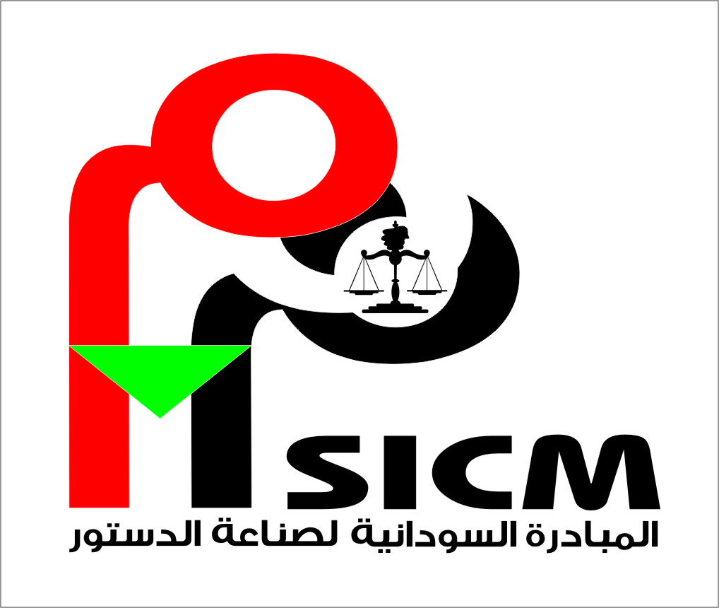

Declaration of the General Constitutional Principles

Sudanese people are the owners of the land, its resources and modes of management. They therefore have every right to delegate all of their powers in this respect by means of a social contract that lays the foundation for a democratically elected parliament, an executive government accountable to all people, an independent Judiciary and total separation of powers for the purpose of attaining peace, security and social welfare.

Sudan’s constitutional moment is a historic and special opportunity. By transforming the negotiation and drafting of the constitution from a legal exercise conducted by political elites into a national dialogue, constitution making can help the Sudanese people develop, strengthen and promote a national identity and foster unity; reach consensus on the core values and fundamental principles of the nation; broaden the reform agenda and convey to the leaders the issues that matter most to the people; build trust between different components of Sudanese society; contribute to national reconciliation; demonstrate a commitment by political leadership and government to democratic principles and processes, while at the same time educate and empower citizens on the principles and practice of democracy, both of which can contribute to creating a new culture of democracy; and lead to a legitimate and effective new constitution.

Signatories of this declaration including political parties and civil society organizations are committed to respect all principles cited herein as part of respect for democracy, equality among citizens, rule of law, and promotion of basic civil, political, economic and social human rights. They are, moreover committed to the following:

First: the State:

Emphasizing that the republic of Sudan is committed to the implementation of the following principles and objectives of:

- National peace and unity, promotion of dialogue as a means for conflict resolution, seeking to attain national reconciliation and bringing to account those responsible for serious violations, reparation of victims and rehabilitation of public utilities.
- Peace, security and stability of citizens.
- Agreement on the concept of identity, non-discrimination among citizens on the basis of whatsoever consideration and respect of social, religious, ethnic and cultural diversity.
- Deeping the principles of good governance, separation of powers precluding their being dominated by a single authority, independence of the Judiciary, and consolidation of basic human principles, rights and freedoms.
- Ensuring the right to sue for all citizens bar none and establishing a legal aid program for the insolvent.
- Development of all economic resources and making them accessible for all citizens to ensure balanced social development and welfare.
- Establishing an executive authority that is committed to transparency, impartiality and accountability and consolidating regional and international cooperation as being imperative for economic, peaceful, cultural and sisterly relations with other peoples and governments.
- Promotion of awareness and dissemination of the culture of democracy, rule of law and tolerance.

Second: the Constitution:

Emphasizing the importance of the constitution, its protection as the supreme law, and the national reference for all citizens and state organs.

- The government is the representative of the people who shall, therefore have the right to bring it to account within the context of equality among citizens, diversity, non- discrimination and ensuring holding free and fair elections under the inclusive observation of all those who are legally eligible to vote.
- Consolidation of religious, political, ethnic, social, cultural and economic diversity in addition to eliminating all forms of discrimination between women and men.
- Protection of mothers, people with special needs, and the elderly.
- Provision of basic needs for all citizens, eliminating poverty, provision of decent means of subsistence, health, transportation, communication, safe environment as well as according special care to groups that labored under forced displacement, political, economic, social and cultural marginalization.
- Enshrining by the constitution of all civil, political, economic, social and cultural rights, in addition to being signatories of all regional and international covenants and conventions.
- Ensuring accessibility of information, the freedom and independence of visual, audio and read media.
- Ensuring the freedom of expression and association for political parties and civil society organizations as well as the freedom of assembly.
- Ensuring separation of Legislative, Executive and Judicial Powers.
- Ensuring the independence of the judiciary for the sake of administering justice, safeguarding the constitution and human rights and making the independence of the post of the Prosecutor –General, which is concerned with criminal prosecution, immune against any political influence.
- Ensuring that the armed forces, the police, prison authorities and national security services discharge their duties as national institutions that are concerned with keeping citizens and states secure and that they are legally accountable.

The Constitution-Making Process:

Affirming that the process to draft and negotiate the new Constitution shall be based on the following principles:

- National ownership;
- Dialogue, negotiation and reconciliation among the peoples of Sudan;
- Inclusiveness: An inclusive constitution making process is one that reflects the diversity of Sudan, and where representatives of all components of society are, wherever possible, given a seat at the table so that each has a hand in the negotiation and drafting of the document and each feels secure as a valued component of the new nation;
  - Political parties, civil society organizations, professional associations, and youth groups, different ethnic, linguistic, cultural and religious groups, women, and diaspora must be able to meaningfully participate in and contribute to the constitution making process;
- Public participation: A participatory constitution-making process is one where the people are educated about the process and the choices being decided, and are given a free, fair, and genuine opportunity to directly express their will in a secure forum that is facilitated by those tasked with analyzing and incorporating the people’s views into the constitutional draft. Education and awareness raising should be conducted by both official bodies and civil society;
- Transparency: A transparent constitution-making process is one that is conducted in an open manner so it is easy for the public to see what actions are performed and people are aware of what is happening at each stage of the process and are confident that their voices are heard. Transparency requires, as much as appropriate, access to constitution making documents and proceedings by the media and general public;
- Consensus: A constitution making process based on consensus is one where decisions are reached by drafting and ratifying bodies based on discussion, negotiation, and persuasion, and only as a last resort by majority rules;
- Education and empowerment of citizens on the principles and practice of democracy through civic education and participation in the constitution-making process;
- Commitment by political leadership or government to democratic principles and processes;
- Sufficient time and resources to conduct a constitution-making process that is genuinely inclusive and participatory;
- A free exchange of ideas on all constitutional matters, including:
  - Bill of rights;
  - The status and role of religion in the Constitution and the state;
  - Separation of powers;
  - Structure of the state, including checks and balances
  - Accountability of government;
  - Federalism, division of responsibility and devolution of power;
  - The institution, status and role of traditional leadership;
  - Demarcation of state and regional boundaries;
  - Revenue sharing and natural resource management;
  - Land ownership and use; and
  - Independent institutions and commissions on issues such as finance, anti-corruption, land, women, human rights, and elections.
That these principles and others that should be agreed to and enshrined in a national law or other legal instrument.

